**Project 1 : Australian Fatal Road Accident 2018 - 2021**

For this project, I investigated the 4 years of road accidents in Australia between 2018-2021. The numbers can vary greatly because of the Covid event that happened at the end of 2019.   
We will see the numbers of 2 years without Covid-19 and another 2 years in the era of Covid-19.

The Australian Road Deaths Database provides basic details of road transport crash fatalities in Australia as reported by the police each month to the State and Territory road safety authorities. Road deaths from recent months are preliminary and the series is subject to revision.

**Research Questions:**

* Does the age of the driver affect the accident?
* Does the gender of the driver affect the accident?
* Compare the accidents that occurred in each state.
* Accidents happen more during the day or at night?
* Do more accidents happen during Christmas?
* Do more accidents happen during Easter?

**Hypothesis:**

* The alternative hypothesis (Ha) is that there is a significant correlation between age of the driver and accident on the road.
* The null hypothesis (H0) is that there is not a significant correlation between age of the driver and accident on the road.

Link to the datasets Kaggle, Australian Fatal Road Accident 1989-2021

<https://www.kaggle.com/deepcontractor/australian-fatal-car-accident-data-19892021/version/2>

**Analysis of accident data in Australian Fatal Road Accident 2018 - 2021**

The dataset of Australian Fatal Road Accident 2018 – 2021. It shows what happened significantly, such as age, gender, day night, holidays (Christmas or Easter) or in each state does it affect the amount of accidents that occur.

First, let's check the completeness of the information obtained. The data from the Kaggle website is for the 1989-2021 Australian Fatal Road Accident. I would choose to analyse only the four years, 2018-2021, because it was the year before the outbreak of coronavirus and the year in which it was during the Covid era and from the graph (Visualizing the Nothing in Dataset of Australian Fatal Road Accident 2018-2021), it shows the completeness of the data that has an empty value of how much is appropriate to be analysed?

From reading the data from the graph, the most empty sections are Heavy Rigid Truck Involvement, National Remoteness Areas, SA4 Name 2016, National LGA Name 2017, National Road Type, are not analysed therefore had no effect on the analysis.

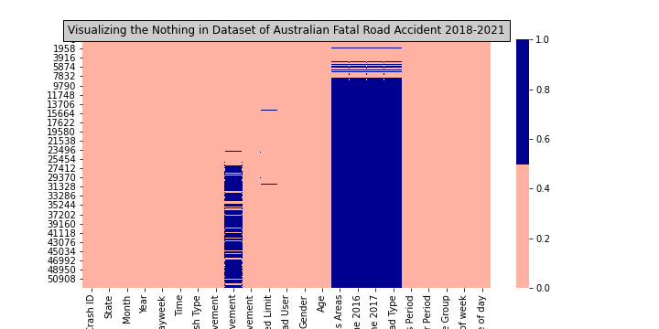

**Research Answers:**

* **Does the age of the driver affect the accident?**

Information from data sets and the graph (Accidents occurring in each age range in Australian Fatal Road Accident 2018-2021) show that the highest rate of accidents were from 19 years of age and decreases the older they get. As accidents tend to decrease with age it appears that age is a factor of accident rates.

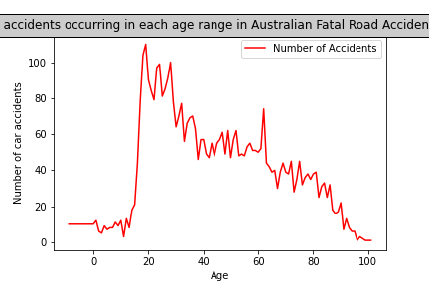

* **Does the gender of the driver affect the accident?**

Data from the pie graph (Gender of the driver in Australian Fatal Road Accident 2018-2021). It was shown that the number of male drivers involved in accidents was greater than that of female drivers. Male drivers accounted for 74.5% and female drivers accounted for only 25.5% of accidents. therefore, having a significant effect on accidents.

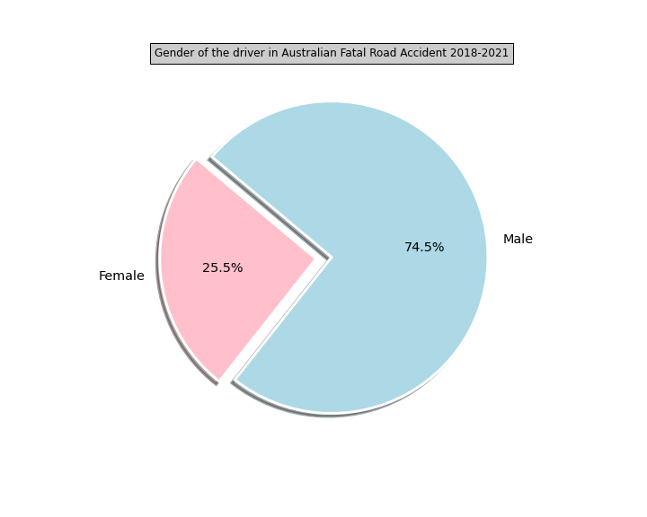

* **Compare the accidents that occurred in each state.**

Data from the bar graph (Number of car accidents occurring in each state in Australian Fatal Road Accidents 2018-2021) shows how many accidents in each state. The highest number of accidents occurred in New South Wales, followed by Queensland and next is Victoria. The data shows a state with high density significantly increases the likelihood of accidents.

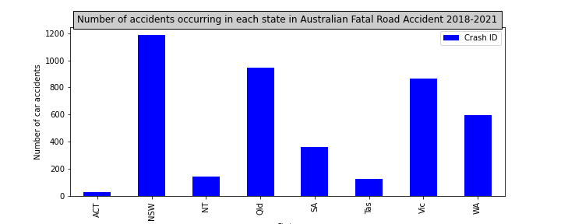

* **Accidents happen more during the day or at night?**

Data from the graph (Time of Day in Australian Fatal Road Accident 2018-2021). It was shown that more accidents occurred during the day than at night. 61.1% of accidents occur during the day and 38.9% of the accidents occur at night. May have to compare the number of road users during the day and the night to find the percentage of accidents per number of road users during that period.

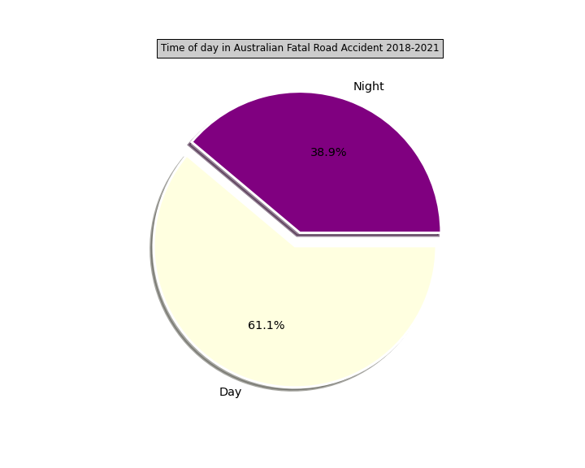

* **Do more accidents happen on Christmas Day?**
* **Do more accidents happen on Easter Day?**

Christmas and Easter Holidays is a festival that is celebrated across the month. The Christmas season is between December and January and Easter is between March and April. By data from the graph (The number of accidents each month in Australian Fatal Road Accident 2018-2021) shows that the most accidents occur in March. Thus, the Easter season may have a significant effect on the festivities causing most road accidents during this period.

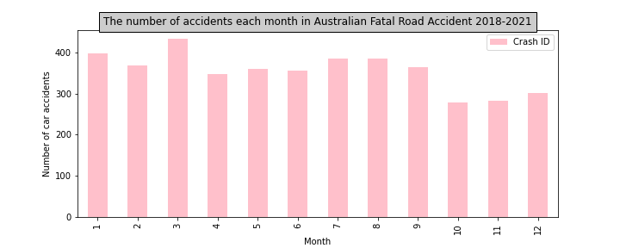

**Hypothesis:**

* The alternative hypothesis (Ha) is that there is a significant correlation between age of the driver and accident on the road.
* The null hypothesis (H0) is that there is not a significant correlation between age of the driver and accident on the road.

The data from the linear graph (Number of accidents occurring in each age range in Australian Fatal Road Accident 2018-2021) shows the trend of accidents compared to the age of the driver. Newly licensed drivers are at the highest risk of causing accidents. The older the driver significantly shows the reduction of the accident rates. Therefore, age and the amount of incidence were significantly related.

